Parth Shukla
190905104

#include <mpi.h>
#include <stdio.h>
#include <stdlib.h>
#include <string.h>

void main(int argc, char *argv[])
{
int rank, size;
MPI_Init(&argc, &argv);
MPI_Comm_rank(MPI_COMM_WORLD, &rank);
MPI_Comm_size(MPI_COMM_WORLD, &size);
long fact;
long i, n;
long rec;
long arr[100], facts[100];
if (rank == 0)
{
n = size;
printf("Enter the numbers: \n");
for (i = 0; i < n; ++i)
{
scanf("%ld", &arr[i]);
}
}
MPI_Scatter(arr, 1, MPI_LONG, &rec, 1, MPI_LONG, 0,
MPI_COMM_WORLD);
printf("Process [%d] received = %ld.\n", rank, rec);
fact = 1;
for (i = 2; i <= rec; ++i)
{
fact *= i;
}
MPI_Gather(&fact, 1, MPI_LONG, facts, 1, MPI_LONG, 0,
MPI_COMM_WORLD);
if (rank == 0)
{
printf("Sum of factorials = ");
long sum = 0;
for (i = 0; i < n; ++i)
{
sum += facts[i];
printf("%ld %s", facts[i], (i != n - 1) ? "+ " : " ");
}
printf(" = %ld\n", sum);
}
MPI_Finalize();
}

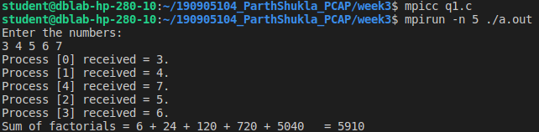

2)
#include <mpi.h>
#include <stdio.h>
#include <math.h>
int main(int argc, char **argv)
{
MPI_Init(NULL, NULL);
int size;
MPI_Comm_size(MPI_COMM_WORLD, &size);
int rank;
MPI_Comm_rank(MPI_COMM_WORLD, &rank);
int A[100], m = 3;
float B[100];
if (rank == 0)
{
printf("Enter M: ");
scanf(" %d" , &m);
printf("Enter %d size array: \n", size * m);
for (int i = 0; i < size * m; i++)
{
scanf(" %d", &A[i]);
}
}
int c[m];
float avg = 0;
MPI_Scatter(A , m ,MPI_INT, &c , m, MPI_INT, 0 , MPI_COMM_WORLD);

for(int i = 0; i < m; i++){
avg+=c[i];
}
avg/=m;
printf("Process %d outputs %.1f\n" , rank , avg);
MPI_Gather(&avg , 1 ,MPI_FLOAT, B , 1, MPI_FLOAT, 0 ,
MPI_COMM_WORLD);
if(rank==0){
float tavg = 0;
for(int i = 0; i < size; i++){
tavg += B[i];
}
tavg /= size;
printf("The total average is : %.1f\n" , tavg);
}
MPI_Finalize();
}

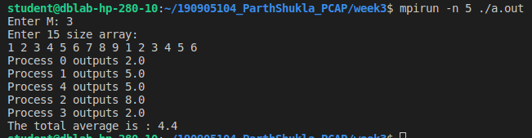

3)
#include <mpi.h>
#include <stdio.h>
#include <string.h>
int main(int argc, char *argv[])
{
int rank, size;
int count = 0;
int b[100] = {0};
int i, n, l;
char str[100], c[100];
MPI_Init(&argc, &argv);
MPI_Comm_rank(MPI_COMM_WORLD, &rank);
MPI_Comm_size(MPI_COMM_WORLD, &size);
if (rank == 0)
{
n = size;
printf("Enter the string: ");
scanf("%s", str);
l = strlen(str) / n;
}
MPI_Bcast(&l, 1, MPI_INT, 0, MPI_COMM_WORLD);
MPI_Scatter(str, l, MPI_CHAR, c, l, MPI_CHAR, 0, MPI_COMM_WORLD);
count = 0;
for (i = 0; i < l; ++i)
{
if (c[i] == 'a' || c[i] == 'e' || c[i] == 'i' || c[i] == 'o' || c[i] == 'u')
continue;
count += 1;
}
printf("Process %d Count = %d\n", rank, count);
fflush(stdout);
MPI_Gather(&count, 1, MPI_INT, b, 1, MPI_INT, 0, MPI_COMM_WORLD);
if (rank == 0)
{
int tcount = 0;
for (i = 0; i < n; i++)
tcount += b[i];
printf("Total non vowels = %d\n", tcount);
fflush(stdout);
}
MPI_Finalize();
}

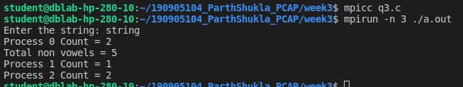

4)

#include <mpi.h>
#include <stdio.h>
#include <string.h>
int main(int argc, char *argv[])
{
int rank, size;
float avg = 0;
char b[100], str1[100], str2[100], c1[100], c2[100], concatted[100];
int i, j, m;
MPI_Init(&argc, &argv);
MPI_Comm_rank(MPI_COMM_WORLD, &rank);
MPI_Comm_size(MPI_COMM_WORLD, &size);
if (rank == 0)
{
printf("Enter string 1: ");
scanf("%s", str1);
printf("Enter string 2: ");
scanf("%s", str2);
m = strlen(str1) / size;
}
MPI_Bcast(&m, 1, MPI_INT, 0, MPI_COMM_WORLD);
MPI_Scatter(str1, m, MPI_CHAR, c1, m, MPI_CHAR, 0,
MPI_COMM_WORLD);
MPI_Scatter(str2, m, MPI_CHAR, c2, m, MPI_CHAR, 0,
MPI_COMM_WORLD);
int t = 0;
for (t = 0; t <= 2 * m; t += 2)
{
concatted[t] = c1[t / 2];
concatted[t + 1] = c2[t / 2];
}
concatted[2 * m] = '\0';
MPI_Gather(concatted, 2 * m, MPI_CHAR, b, 2 * m, MPI_CHAR, 0,
MPI_COMM_WORLD);
if (rank == 0)
{
b[m * size * 2] = '\0';
printf("Concatted:%s\n", b);
}
MPI_Finalize();
}

